MINI PROJECT – I SYNOPSIS



Department of Computer Science & Application

**Institute of Engineering & Technology**

SUBMITTED TO :- Mr. Vikas Kumar ( Technical Trainer )

SUBMITTED BY :- Aman Kumar ( 201500073 )

Subrat Jain ( 201500711 )

Divyansh Bhargava (201500231)

Shyam Ji Gupta (201500687)

Harshit Singh (201500286)

# Acknowledgement

It is a pleasure for us to present the Mini project which is made during B. Tech 3rd Year ( 5th Semester ). We take this opportunity to express our deep sense of gratitude and respect towards our mentor, Mr. Vikas Kumar, Technical Trainer, Computer Science & Engineering Department, for encouraging and motivating us to develop this project.

His sincerity and determination has been a constant source of inspiration for us. We also believe that he will empower us with all his great innovative ideas and different stages of the project. We would not like to miss the opportunity to thank and acknowledge the contribution of all the faculty members of the department for their kind guidance and co-operation.

Aman Kumar ( 201500073 )

Subrat Jain ( 201500711 )

Divyansh Bhargava (201500231)

Shyam Ji Gupta (201500687)

Harshit Singh (201500286)

## Declaration

We hereby declare that the work which is presented in this project entitled **‘Online Mario Game’** in partial fulfilment for the award of degree Bachelor of Technology in Computer Science Department , **GLA University, Mathura**, is our work carried out for a period of **September 2022 to November 2022** under the guidance of Mr. Vikas Kumar ( Technical Trainer ) GLA University, Mathura.

Aman Kumar ( 201500073 )

Subrat Jain ( 201500711 )

Divyansh Bhargava (201500231)

Shyam Ji Gupta (201500687)

Harshit Singh (201500286)

# TITLE

**Online Mario Game**

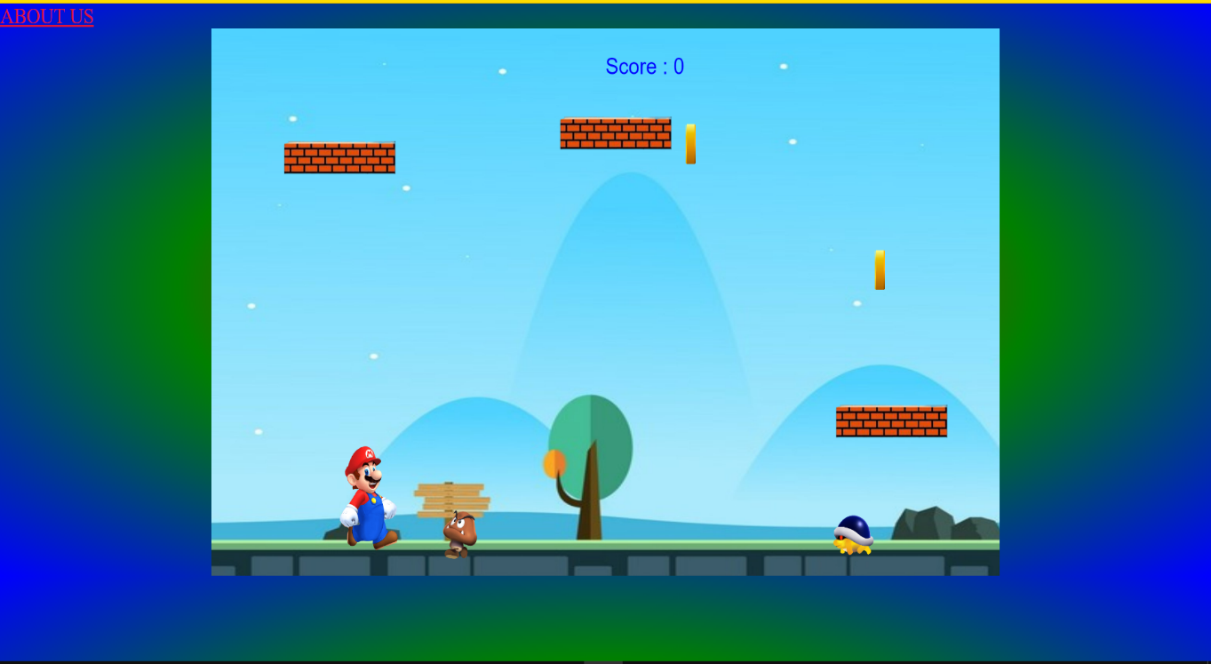

**Project Introduction**

Being a GLAian I can surely assure is a blessing, since there are a number of highly knowledgeable and interactive faculties that solve most of our daily problems. Still there are certain instances, maybe some lines of code, maybe a formula, or some silly doubt which cannot be solved by professors for each and every one. This created the need of a platform where all students can post questions and get their answers or help others by reviewing their code. This helps in developing coding atmosphere and overall growth of the community.

**Aims and Objectives**

The need of a platform which provides personalized solutions to the students of GLA University. This platform should be free and be available 24/7. The platform (preferably a website) should be for the students and by the students. Therefore every student must be able to login the website and post their questions or answer the queries posted by others.

The biggest objective is to motivate the students who feel underconfident in coding. Getting their queries resolved and discussing them among peers can help them grow slowly and steadily. They can also use hide me feature to hide their identity if they feel too shy or embarrassed to ask silly doubts (coding and technical doubts only).

**Working**

There are two main modules in the project

## User Login

The users enter their login credentials and get

access to the website.They can get access through their official email address

Therefore the website is equipped with user identification and authentication.

## Reading and Uploading posts :

This module is concerned with reading others responses, uploading own posts, editing and deleting them and liking others posts .

Users can add maximum five tags to their posts to enable quick search .

This also helps in sorting of posts on the basis of topics. They can edit or delete their post anytime.

Users can rate the answers that they like and comment on post of other users

**SOFTWARE AND HARDWARE REQUIREMENTS**

* Web Browser ( Chrome , Brave , Firefox, MS Edge etc )
* Visual Studio Code
* 2 GB RAM ( Minimum )
* Window 7 ( Minimum )

## IMPLEMENTATION

Java script is a scripting language used to enhance the functionality of the browser. Java script is integrated with HTML and navigator

* 1. Java script facilitates the developer with properties related to document windows, frames,animation,play media contents, loaded documents and link.

For the frontend , we use javascript to create web application. The biggest advantage of using it is the hot reload feature and the reusable components **.**

**REFERENCES:**

**Websites:**

* + - [www.w3schools.com](http://www.w3schools.com/)
    - <https://www.geeksforgeeks.org/>
    - www.beta-labs.in

**Faculty Guidelines:**

Mr. Vikas Kumar (Technical Trainer in GLA University)

**GitHub Repository link:**

[**https://amankumar7878.github.io/marioGame/**](https://amankumar7878.github.io/marioGame/)